**AZURE PROJECT**

Create 2 virtual machines (deploy an application). Create a virtual machine (configure MySQL database). Connect the 2 VMs with the database and create tables on it. 2 VMs should have load balancing and autoscaling and map a domain in it.

**STEPS TO CONFIURE ARE AS FOLLOWS: -**

* ***Created a resource group.***
* ***A virtual network was created it with 2 subnets (all VMs were created under one subnet and the other was the gateway subnet).***

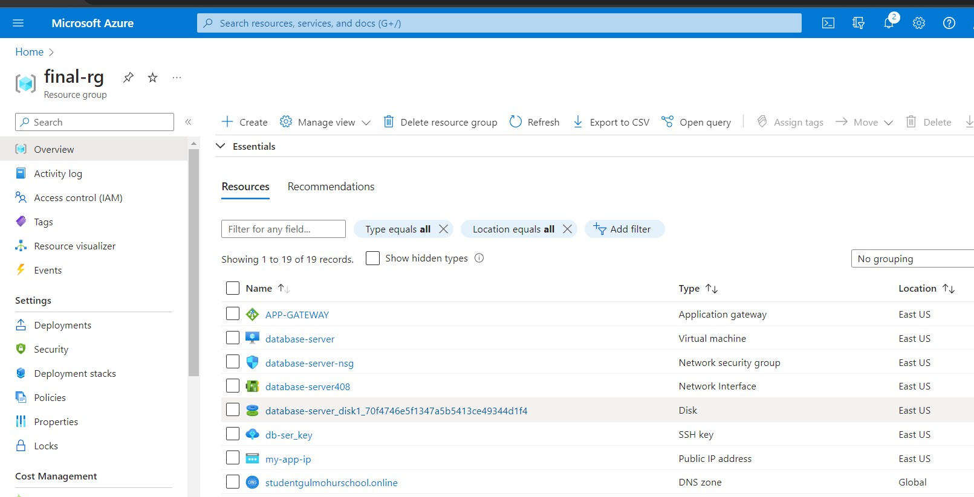

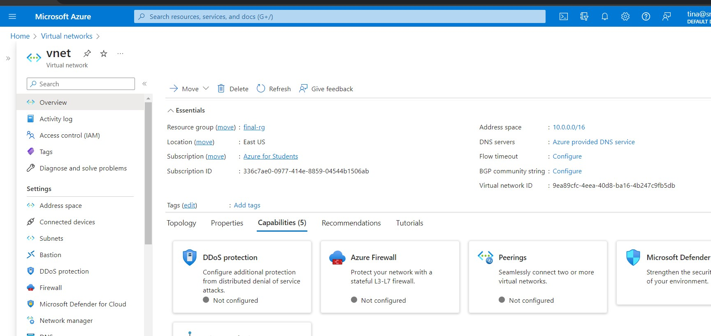

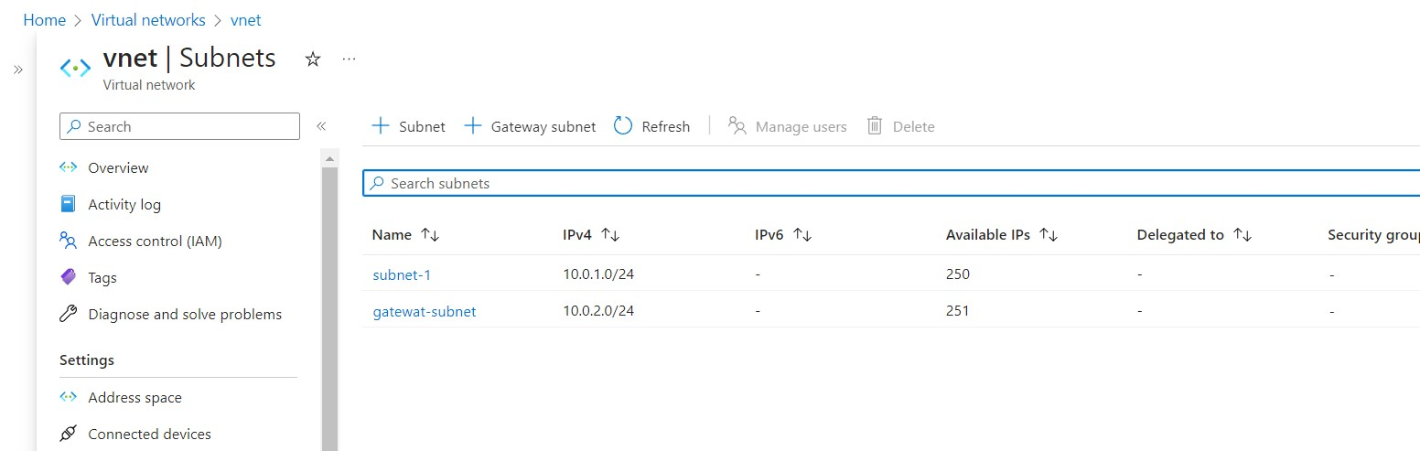

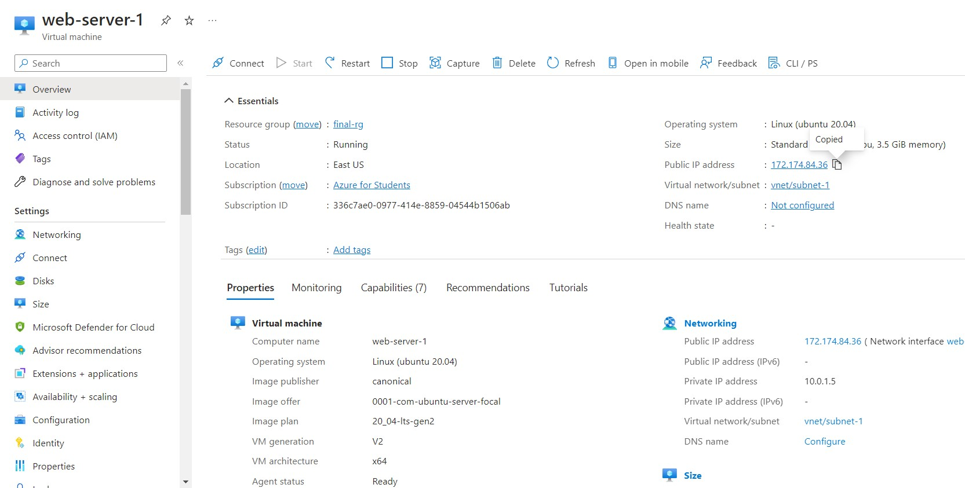

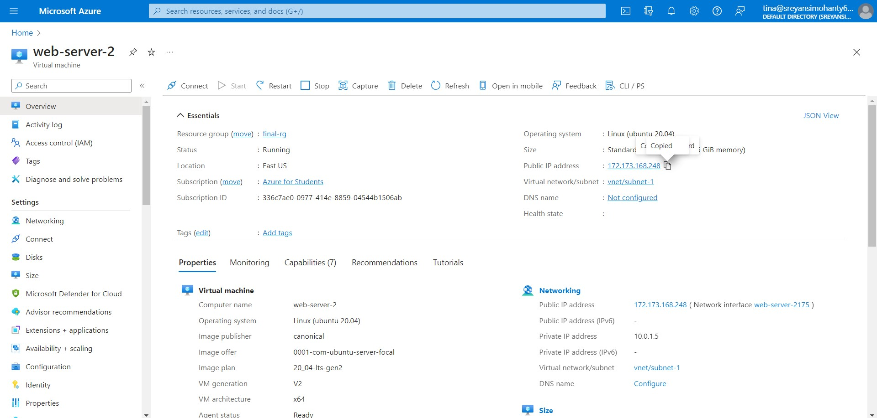

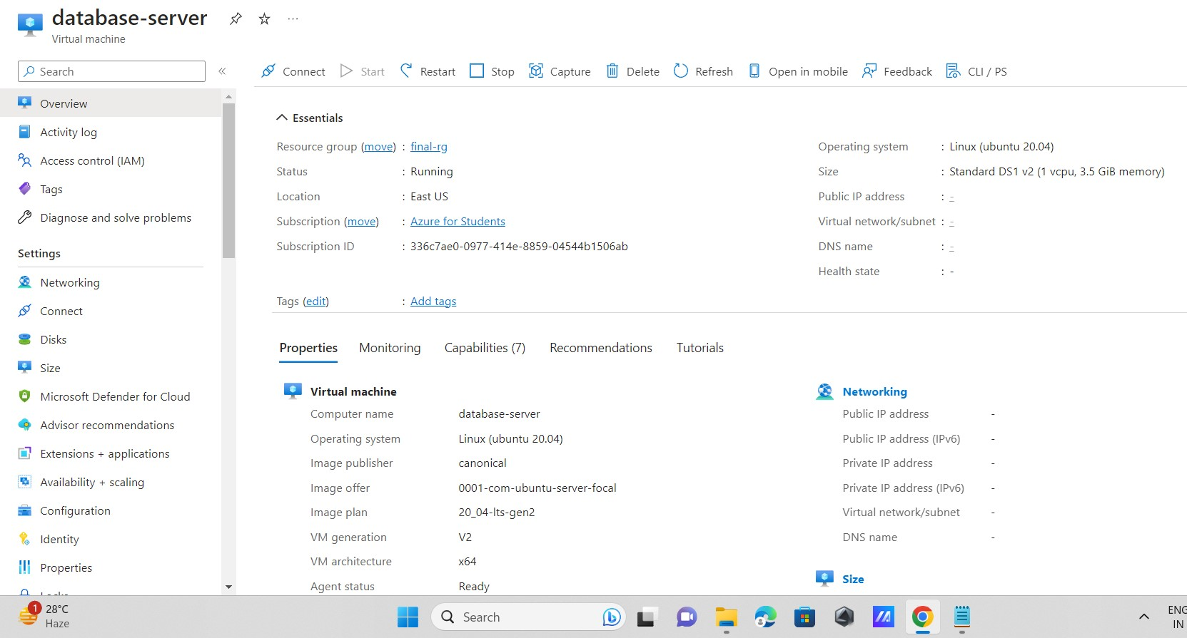

* ***The 2 VMs were configured as web server by installing apache2 as it was ubuntu server.***

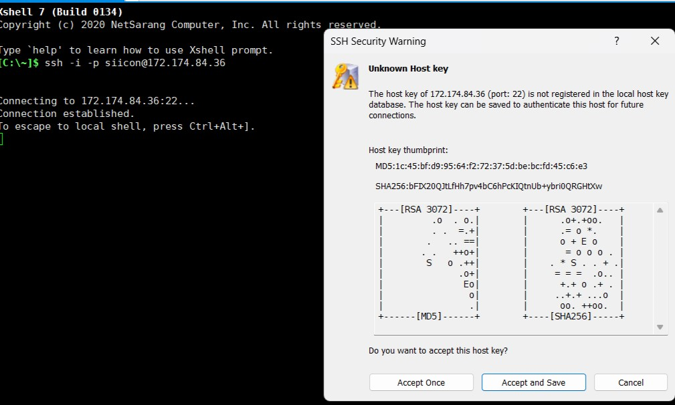 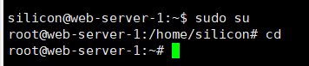 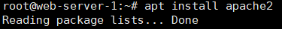

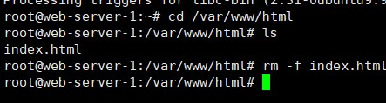

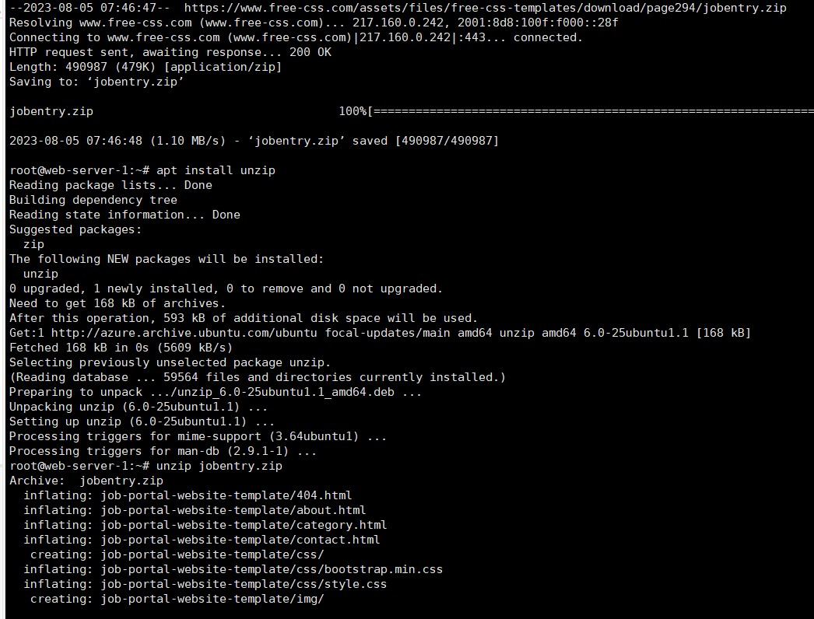

* ***After configuring as web-server, we got the contents of the website as follows. The same steps were followed to configure the VM 2 as web server.***





* ***The contents of second web-server is: -***

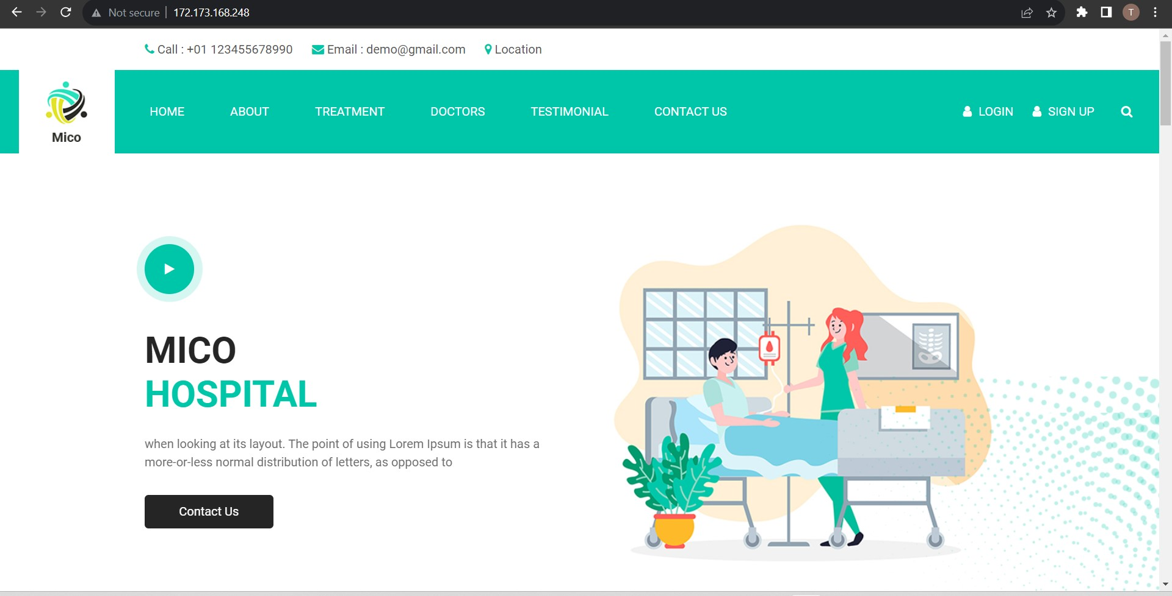

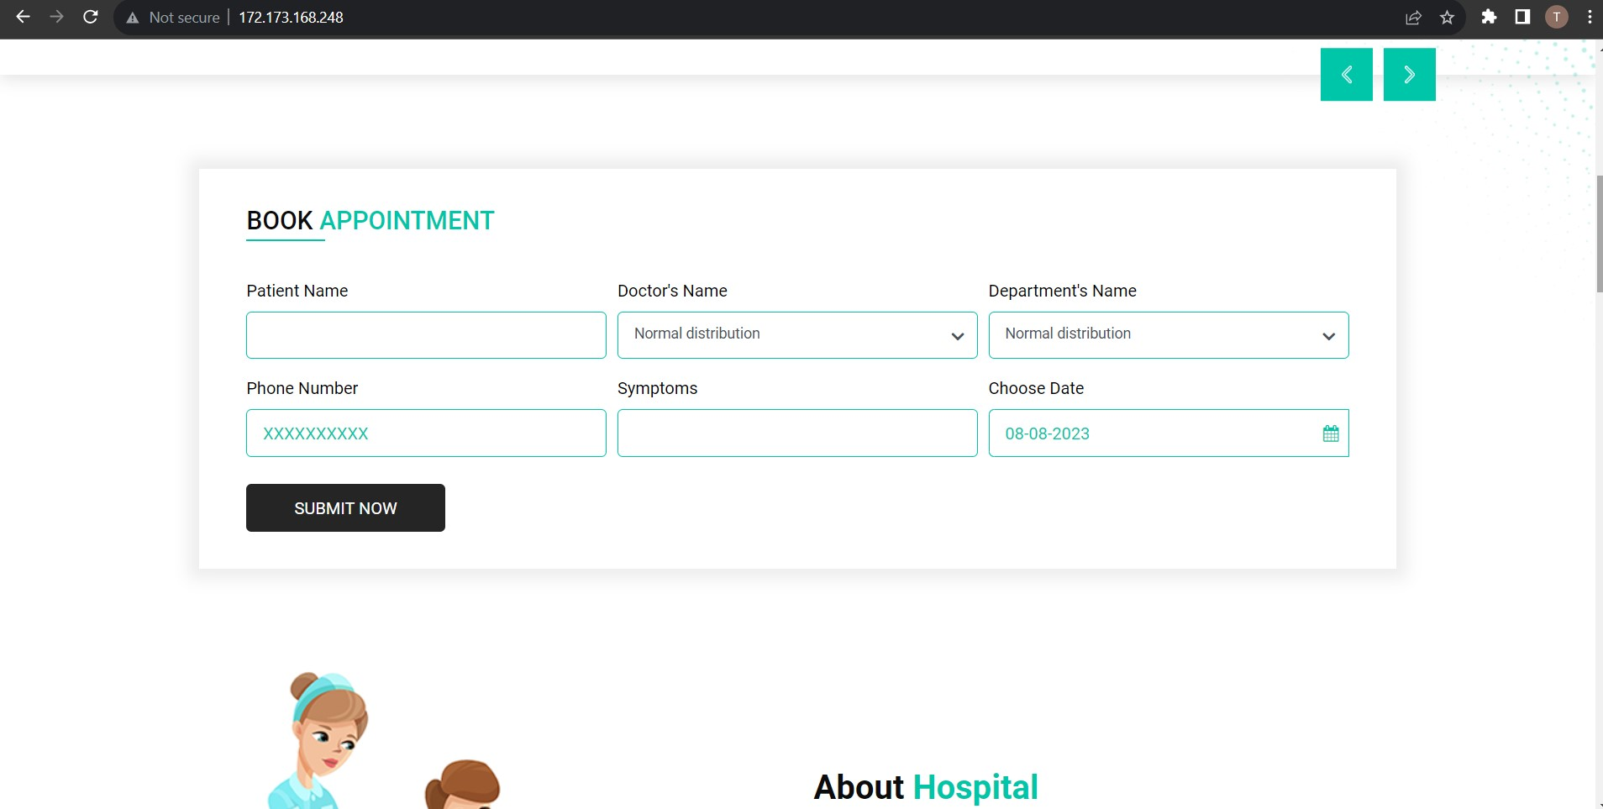

* ***Then we connected to the database server (configured it as MYSQL database server) from the web-servers.*** 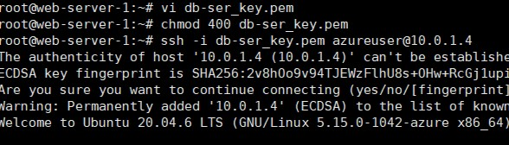

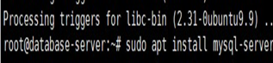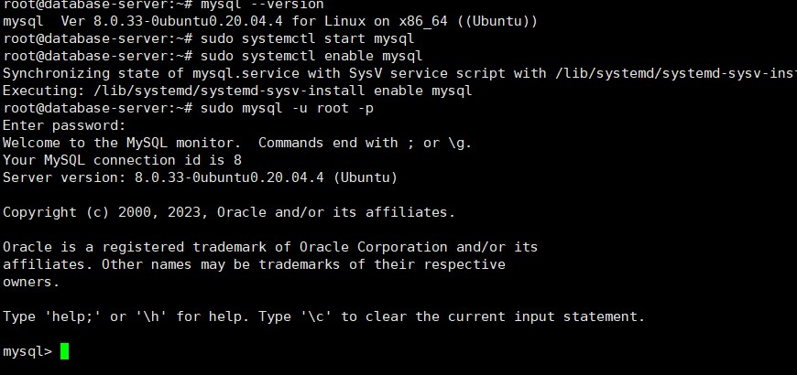

* ***After connecting to MYSQL database, we could the see the database present in it. To check, follows the command:***

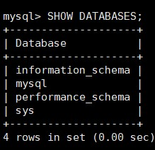

* ***Then we created our own database inside MYSQL and created tables.*** 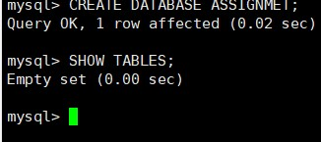

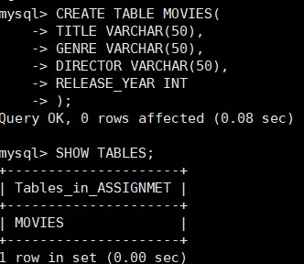 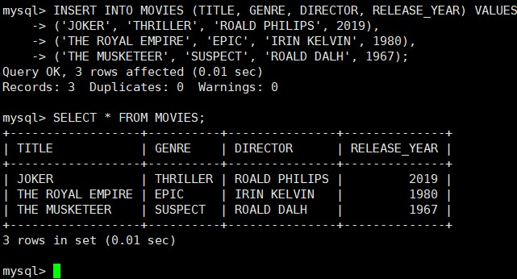

* ***Then we connected to same database from second web-server and created another table. While creating table in MySQL database from the second server we saw that the table we created from first server was available in the database we created.***

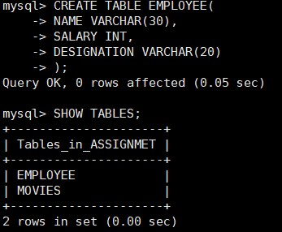 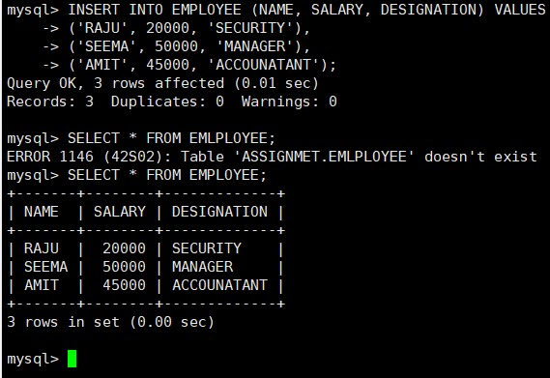

* ***The final tables after creation.***

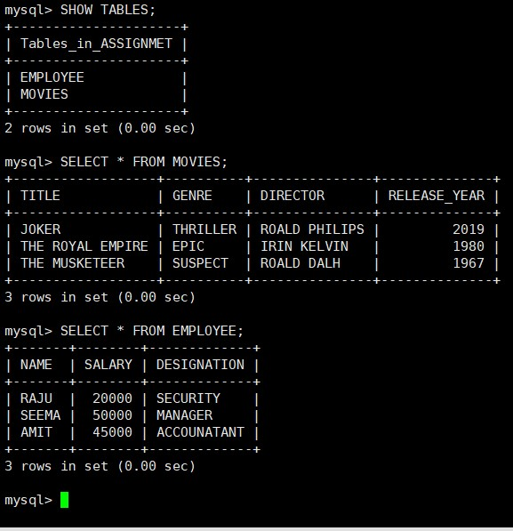

* ***We created and application gateway to balance the traffic on the 2 web-servers to balance the traffic.***

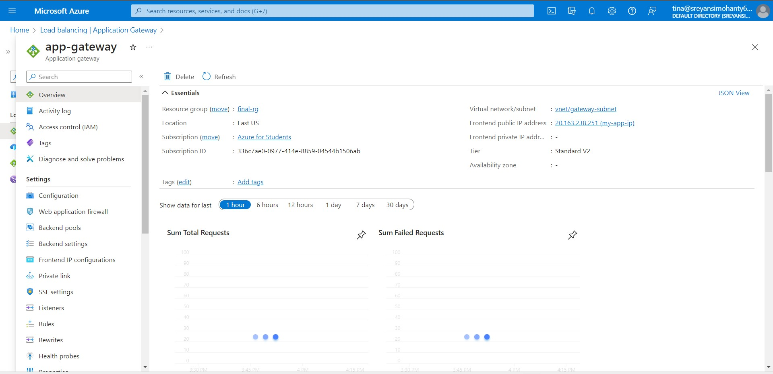



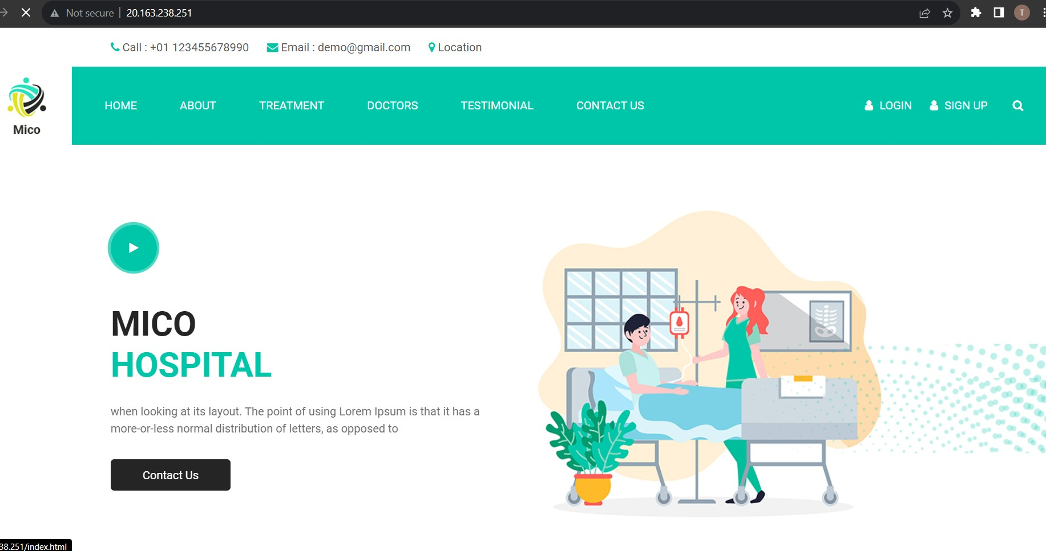

* ***Purchased a domain name from hostigner.***

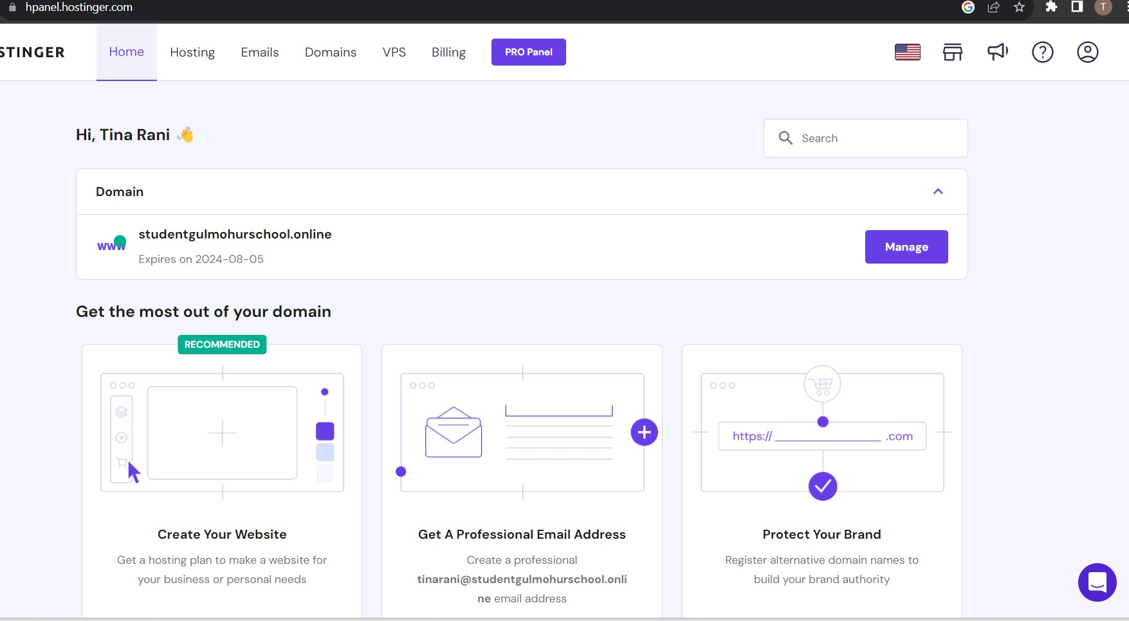

* ***Created a DNS zone and mapped domain name with website.***

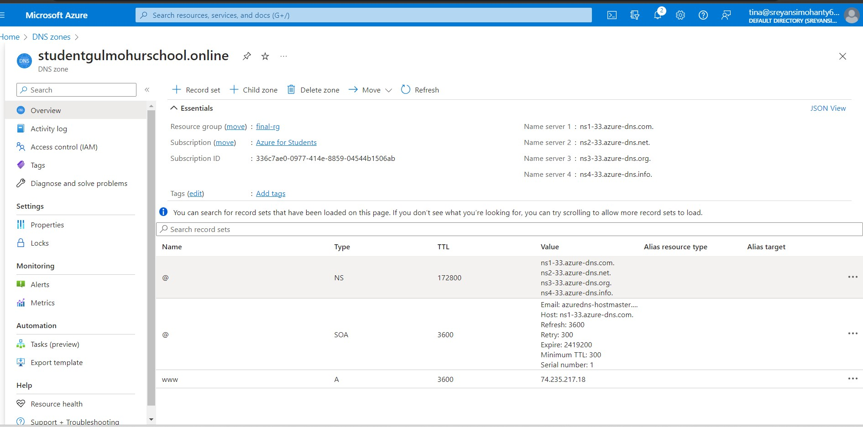

* ***Through Cloudflare we obtained SSL certificate and attached it with the application gateway to acquire security to the web-servers.***

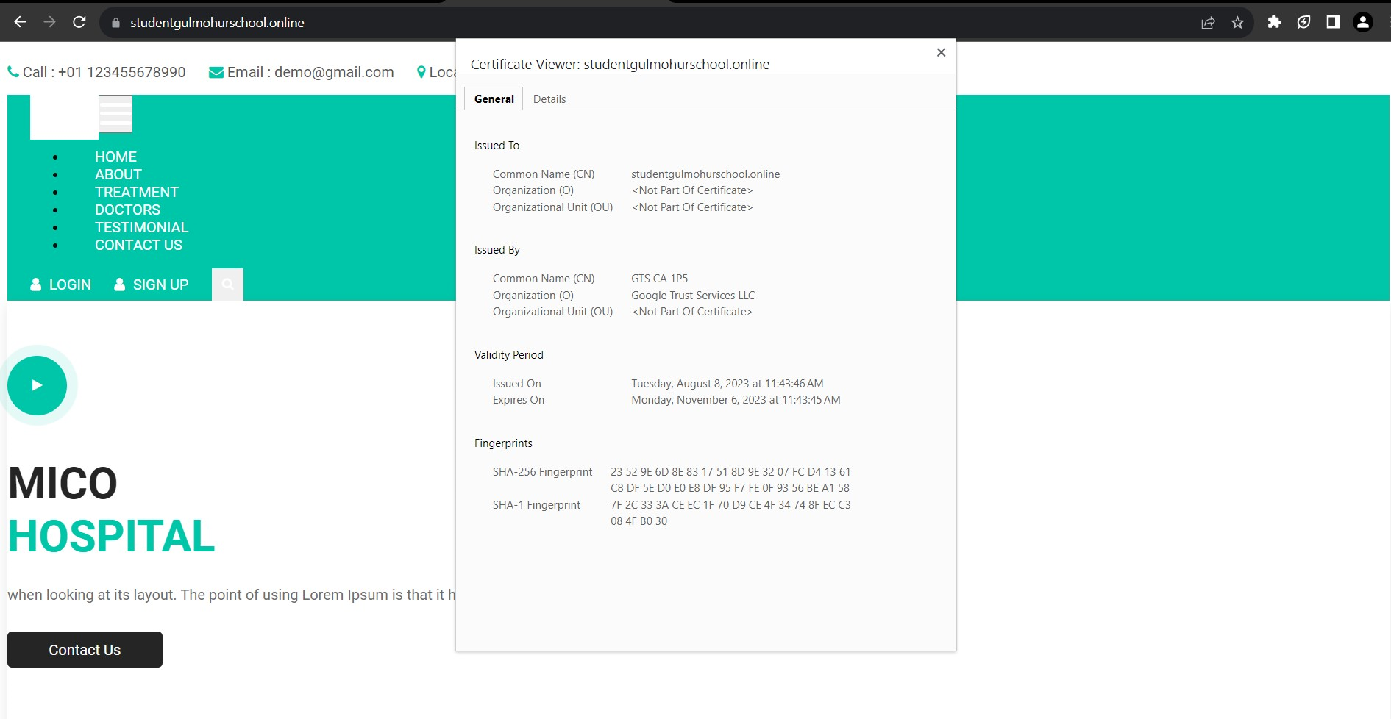



**SUBMITTED BY: -TINA RANI MAHATO**

**BRANCH: -CEN**

**SIC NO: -21BECC50**